**CONTENT MANAGEMENT SYSTEM**

A content management system (CMS) is software that helps users create, manage, and modify content on a website without the need for technical knowledge. In other words, a CMS lets you build a website without needing to write code from scratch (or even know how to code at all).

OR

A content management system (CMS) used to create, edit, organize and publish content. CMS helps organizations to manage digital content.

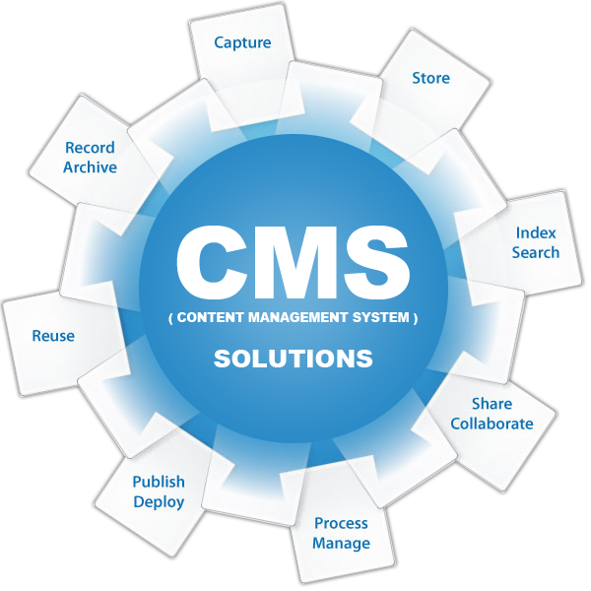

**Kinds of Websites Can You Build with CMS: -**

* Static websites
* Blogs
* eCommerce stores
* Forums
* Social networks
* Online courses
* Membership sites
* Portfolios
* Etc.

Popular CMS tools - **AEM/Word Press/Joomla/Drupal/WIX**

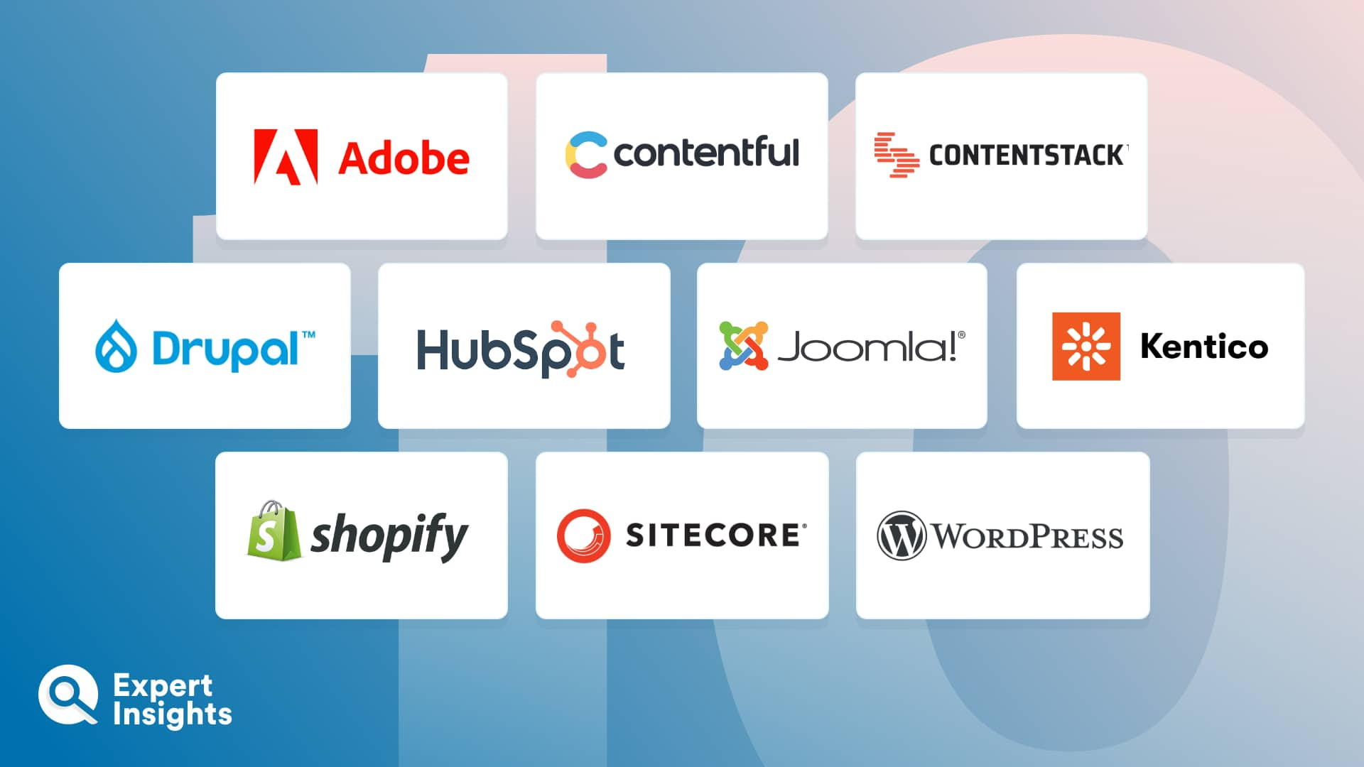

**Types of CMS**

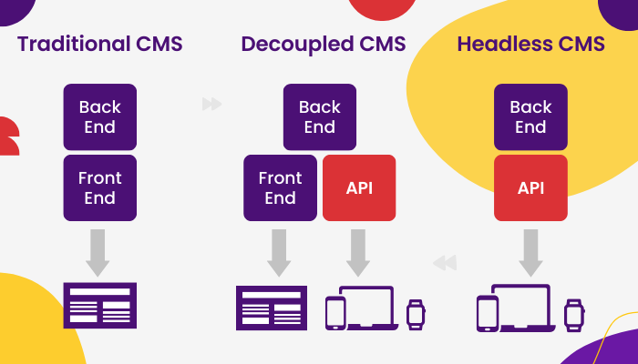

1. **Traditional CMS –**

a) **Coupled CMS** – “when your logic or functionality is binded to your rendering frame work ”.

b) **Decoupled CMS** –“when your backend functionality means content delivery functionality not tightly binded with rendering functionality ”.

1. **Headless CMS -** when CMS can deliver only content not the rendering functionality
2. **Hybrid CMS -** Combination of traditional + headless

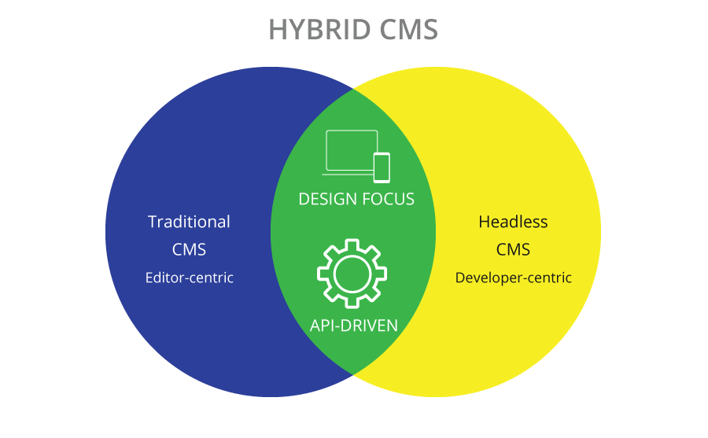

**Why CMS?**

Nowadays websites are very dynamic, and we have to update the content very frequently. So, its easier to manage the content of such website using various CMS applications/tools – AEM

**AEM (Adobe Experience MANAGER)**

AEM is a comprehensive content management solution. Used for building websites, forms, and mobile apps. Its is used to make your marketing content and assets easily manageable.

OR

AEM is content management system that lets you create website, mobile apps, and forms. Its simple   
to manage your marketing content and assets with AEM.

OR

AEM is a web-based CMS which enables organizations to create websites, manage content and digital assets of the website through several medium like mobiles web browser, tabs, desktop etc.

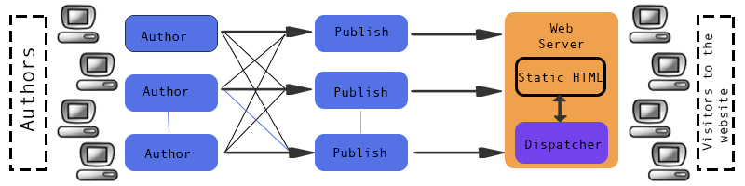

**Advantages or Features of AEM**

1. Content authoring and management.
2. Multi-channel collaboration.
3. Workflow management collaboration.
4. AEM provides an easy way to navigate through different pages, assets, templates and elements in the web-page.
5. The UI provided by AEM helps in better personalization.

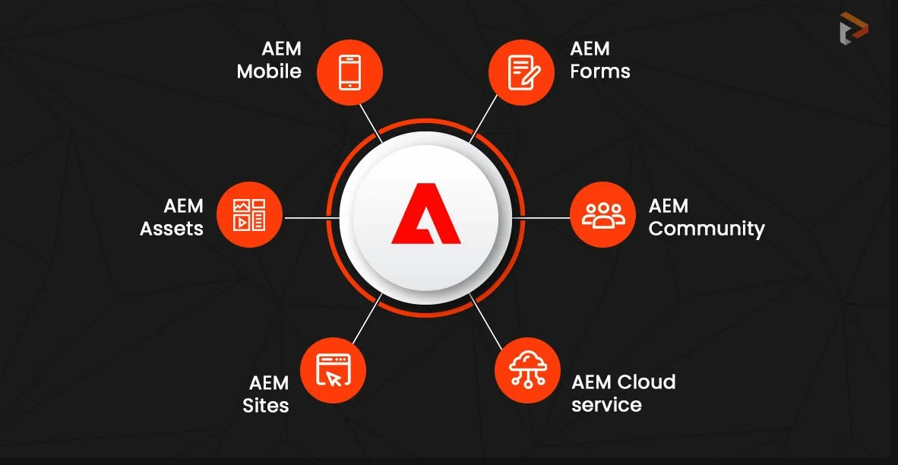**Important Components of AEM**

**Advantages of AEM CMS over other CMS**

* AEM can create custom digital experiences personalized to individual user.
* AEM provide best-in class features such as Content workflows, digital asset management (DAM), social and multi-channel collaboration etc.
* AEM allows user to manage digital content easily and effectively.
* AEM also provides a way to manage mobile applications, mobile website ,e-commerce, and making campaign management.